The experiment of Eratosthenes to calculate the Earth's radius
This experiment is considered as one of the 10 most beautiful scientific experiments in the history of physics! Observations and measurements of each group of students can be carried out in the school yard.
Objectives
Involvement of students in an activity of great interest, exchange of data and interdisciplinary approach (the process of observations, measurements and calculations involved in cognitive area of several school subjects like Physics, Geography, Mathematics, ICT).
Preparing activity
The experiment should involve collaboration with a school abroad with which you should get in touch. To perform this activity you will need a computer with internet.
The idea of the experiment
Eratosthenes knew that on the summer solstice in the city of Syini (Egypt), which is located at
Tropic of Cancer, at 12:00 noon exactly the sun is vertically above the region. Considering that the Earth is round conducted the following experiment: In Alexandria, where he was, he placed vertically on ground a rod. When the sun reached its zenith, he measured the shadow of the rod.
Since the sunlight reaching the earth is parallel, the angle between the rod and shade is equal to the angular distance between Alexandria and Syini. Based on this measurement he estimated that the slope of the solar rays in Alexandria is 1/50 of a full circle (7 ° 12 ') north of vertical when the sun is at its zenith.
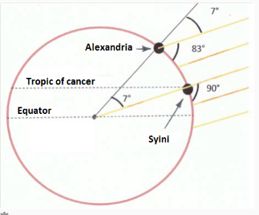

Who was Eratosthenes
Eratosthenes (276 BC - 194 BC) was a Greek mathematician, geographer and astronomer. He was born in Cyrene (today's Libya) and died in Alexandria.He made several important contributions to mathematics and he was a friend of the famous mathematician Archimedes. Around 225 BC invented the armillary sphere, used by the widely until the invention of the planetarium in the 18th century. Around 240 B.C.he calculated the Earth's circumference at 46,615 km.He also devised a system of latitude. Also he invented a method of calculating prime numbers known as the sieve of Eratosthenes.
The term Geography is attributed to Eratosthenes. Other notable activities of Eratosthenes are:
• Measuring the Earth-Sun distance as equals 1 astronomical unit (804 million stages, one stage is from 157 up to 209 meters).
• Measuring the distance Earth - Moon. (780,000 stadia).
• Measurement of the obliquity of the ecliptic.
• Astronomical compilation containing 675 stars.
• Map of the Nile to Khartoum.
• Map of the inhabited world.
Sources: http://www.juliantrubin.com/bigten/eratosthenes.html, http://el.wikipedia.org/

1st Assignment - Time of measurements of the shadow with partner school
To measure the earth radius you should know the distance between two cities (your city and your partner's school city), as well as their angular spacing. Therefore the measurement of the shadow must be made in the two different areas. Measurements at both locations must be made when the Sun is located at the peak of each city and the shadow is the shortest possible length.The time at which the Sun is at the zenith differs from region to region and even in a region varies according to the season. To find the time of measurement, i.e. to find when the sun reaches the zenith day measurement for the area where we are you can go here.
Submit the local times of measurements both for your city and the city of partner's school. Don't forget to mention the name of partner school and its city.

2nd Assignment - Experiment
Each school should measure the angular distance from the equator. Both these angles should necessarily be measured on the same meridian. Exchange your measurements for the angle. Subtracting these two angles, what essentially you get is the angular distance between the locations projected onto the same meridian. Therefore, the distance between 2 schools must be measured on the same meridian, as well.
Measure this distance using the "Google Maps" https://www.google.gr/maps.
Tip for Google Maps: To find the latitude and longitude on google maps, identify the location of the school, press the right mouse button in this box and from the drop down menu select "What's here?". The latitude and longitude values are displayed in the popup window.
Below are some images that may help you understand what you have to do.
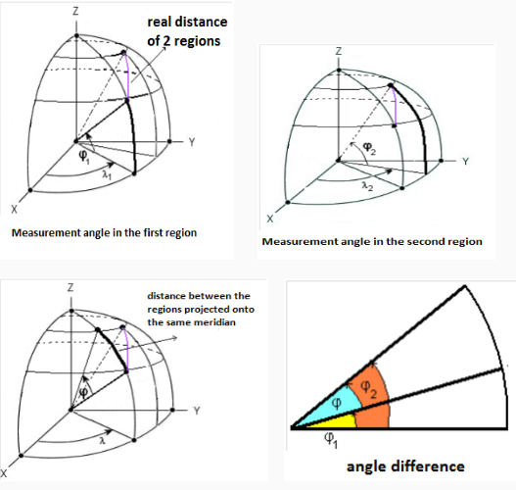
The whole situation should look like:
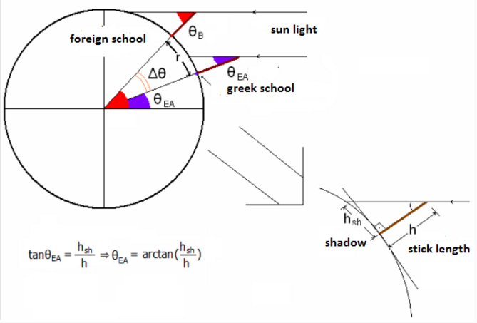
We're having below this assignment in Moolde a EXCEL file that you can use for your calculations.
If for any reason (e.g. cloudy) is impossible to carry out the experiment at noon, it is possible to do it another day, bearing in mind that the sun "moves" the north at a speed of about 1 degree every three days.
After the action you will fill the Excel with the details regarding your observations (object height, length shadow). The measurement results will ship to us by filling out and submitting the Excel file. Some of these elements would like from you to post them on the map and send this map to us. You can also send us one photo with camouflage of students’ faces taking the measurements.

